For Smaller Firms, Recruiting Costs Add Up
Large firms see a significant scale advantage when it comes to recruiting costs per new employee, according to a study from Bersin & Associates, a human-resources advisory firm.
Companies with more than 10,000 employees world-wide pay a median figure of $1,949 per hire, compared with midsize companies, which pay $3,632, and small firms, which pay $3,665.
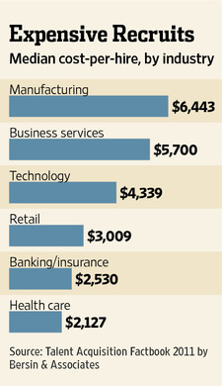
Because small and medium-sized organizations tend to have fewer dedicated recruitment employees, they often have to outsource hiring, which can be very expensive .
Large companies also hire significantly more employees than small and midsize firms relative to the size of the recruitment staff, bringing down the costs.
Of the industries analyzed, manufacturers had the highest recruitment costs per hire, with median spending of $6,443. That's because those jobs require specialized skills like familiarity with particular types of equipment or software..
Health-care companies had the lowest costs, at $2,127, because the skill and certification requirements for many medical positions, such as nurses, are rigidly defined, which simplifies hiring.
To calculate the cost per hire, 414 companies added up all their spending on internal recruiting staff, third-party agencies, company career websites, applicant tracking software, job-listing services, college recruiting, employee referral programs plus other recruiting-related expenses—and divided that number by their total hires over the preceding year.

